WATERSHED INTRODUCTION

Watershed Community Initiative
A watershed is the land area that drains to a common point, such as a location on a river. All of the water that falls on a watershed will move across the landscape collecting in low spots and drainageways until it moves into the waterbody of choice. All activities that take place in a watershed can impact the water quality of the river that drains it. What we do on the land, such as constructing new buildings, fertilizing lawns, or growing crops, affects the water and the ecosystem that lives in it. A healthy watershed is vital for a healthy river, and a healthy river can enhance the community and helps maintain a healthy local economy. Watershed planning is especially important in that it will help communities and individuals determine how best to preserve water functions, prevent water quality impairment, and produce long-term economic, environmental, and political health.

The Wabash River watershed includes all the land that drains into the Wabash River. The river starts in Ohio and drains about 1,024,382 acres by the time it passes through the current watershed project area (Figure 1). The Treaty Creek-Wabash River includes portions of Wabash and Miami Counties in north-centratl Indiana.

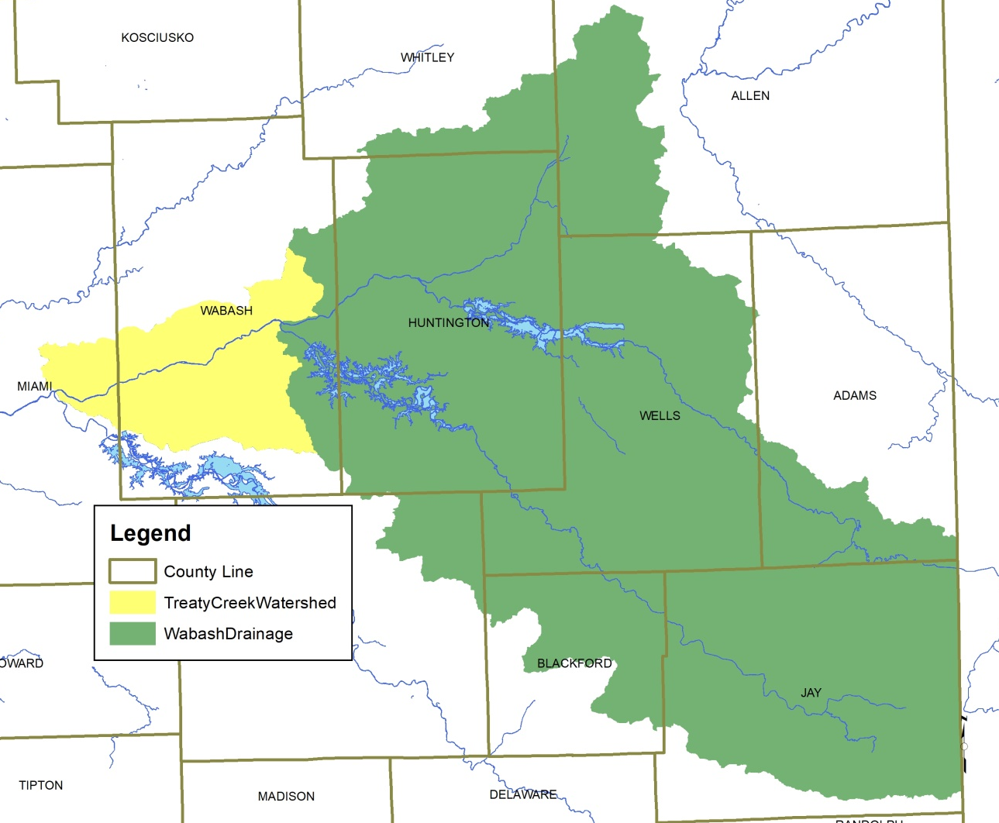
Figure 1. Wabash River watershed highlighting the Treaty Creek-Wabash River Drainage.

Figure 2. Treaty Creek-Wabash River subwatersheds.

Project History
In the fall of 2015, the Wabash River Defenders submitted a grant request to the Indiana Department of Environmental Management with a focus on assessing and improving water quality within the Treaty Creek-Wabash River Drainage within Wabash and Miami Counties, Indiana. The Wabash River Defenders selected the Treaty Creek-Wabash River Watershed as it contained most of the tributaries that drain to the Wabash River within Wabash County. They completed a brief inventory of the watershed and identified several preliminary partners as well as concerns associated with the various practices and uses in the watershed. Specifically, the watershed includes the entire City of Wabash MS4 boundary, which requires the input and participation of the City of Wabash. The watershed is predominantly agricultural with 73% of the watershed covered by row crop agriculture or pasture land, 14% in forest or wetland and 9% in developed land uses including the City of Wabash and Town of Lagro. The engagement of the Miami and Wabash Soil and Water Conservation Districts, Natural Resources Conservation District, and Purdue Extension staff as well as producers across the watershed would be paramount. A majority of the land within the watershed is privately-owned and in a soybean-corn rotation. More than 30 active confined feeding operations are located within the Treaty Creek-Wabash River watershed. These operations house more than 10,000 head of cattle and more than 50,000 head of hogs. Between these animals and those housed on small, unregulated farms, more than 100 tons of manure are produced daily within the Treaty Creek-Wabash River watershed.

Additionally, the Wabash River Defenders completed an initial assessment of the watershed and identified that it contains high nutrient, sediment and E. coli concentrations and limited biotic communities. Assessments completed via IDEM's monthly fixed station sampling at the Wabash River at SR 105, which is upstream of this watershed, indicate that nutrient concentrations routinely exceed target nitrate-nitrogen (75% of samples measure greater than 2 mg/L) and total phosphorus (99% of samples measure greater 0.08 mg/L) concentrations. Additionally, IDEM-collected turbidities measured within the stream indicate higher than target levels (78% of samples measured higher than 25 NTU). In the Wabash River at Lagro, limited nutrient, sediment and E. coli data collected in rotational basin assessments indicate that concentrations are typically higher than the state standard and targets. The source of these issues is currently unknown as only two watershed tributaries have been sampled by IDEM in the past. Sample results from historic sampling efforts indicate impaired biotic communities in Mill Creek, Ridgeway Creek and a tributary to Ridgeway Creek but provide little data for other watershed tributaries. The Wabash River TMDL identifies the following load reductions from nonpoint sources at the Roush Lake sample point: 0% less nitrate, 20% less total phosphorus, and 95% less E. coli (TetraTech, 2008).

The Wabash River Defenders approached commuity groups and individuals throughout the watershed that might be intersted in working with them to assess and improve water quality wihtin the Wabash River. Identified potential partners include: The Community Foundation of Wabash County, Grow Wabash County, City of Wabash Utilities, Visit Wabash County, Indiana American Water, Miami County Soil and Water Conservation District and Natural Resources Conservation Service, Wabash County Surveyors office, Wabash County Soil and Water Conservation District and Natural Resources Conservation Service, Wabash County Purdue Extension, Wabash County Solid Waste Management District, Wabash County Area Plan Commission, Wabash County United Fund, and Wabash County Emergency Management. This group formed a Steering Committee (Table 1), conducted windshield surveys of the watershed, and held several meetings open to the public in order to generate input in the development of a watershed management plan for the Treaty Creek-Wabash River Watershed. All of these efforts were guided by the following mission and vision developed by public participants and committee members:

Mission:

Vision:

The mission and vision are works in progress and may change as the project moves forward.

Stakeholder Involvement
Development of a watershed management plan requires input from interested citizens, local government leaders, and water resource professionals. These individuals are required to not only buy into the project and the process but must also become an integral part of identifying the solution(s) which will result in improved water quality. We involved stakeholders in the watershed management planning process through a series of public meetings, and education and outreach events including windshield surveys, water quality monitoring opportunities, and meetings with local officials.

Steering Committee
Individuals representing the towns and counties within the watershed, environmental groups, natural resource professionals, agricultural and commercial representatives, and private citizens comprised the steering committee. The steering committee has met nearly every other month to develop the WMP, starting in December 2017. Table 1 identifies the steering committee members and their affiliation.

Table 2. Treaty Creek-Wabash River Watershed steering committee members and their affiliation.
Individual | Organization(s) Represented
Bob Gray | City of Wabash
Christine Flohr | Visit Wabash County
Keith Gillenwater | Economic Development Group
Brandon France | Indiana American Water
Mary Lou Musselman | Miami County SWCD
David Grant | Strauss Veal Feeds
Cheri Slee | Wabash County Surveyor
Mike Howard | Wabash County Area Plan
Tashina Lahr-Manifold | Wabash County SWCD
Steve Johnson | Wabash County United Fund
Adam Jones | Wabash County NRCS
Ed Sprunger | Miami County NRCS
Gregg Wilkinson | Miami County Surveyor
Curtis Campbell | Wabash County Purdue Extension
Kimberly Frazier | Miami County Purdue Extension
Jen Rankin | Wabash County Solid Waste
Keith Poole | Wabash River Defenders
Mike Beauchamp | Wabash River Defenders
Bob Brown | Wabash County Emergency Management

Public Meetings
Public participation is necessary for the long-term success of any watershed planning and subsequent implementation effort. One component of public participation for this project was public meetings. There were two public meetings held in January 2018 to introduce the project and develop a concerns list. The purpose of the public meetings was to provide information on the overall planning effort and its progress; solicit stakeholder input, opinions, and participation; create opportunities for the public to recommend programs, policies, and projects to improve water quality; and build support for future phases of the project.

The public meetings were advertised through press releases distributed to local newspapers in the watershed. The meetings were also advertised through word of mouth as staff from the Soil and Water Conservation District put together mailings that advertised the events and the Wabash River Defenders distributed information via their website and social media pages as well as through their email distribution list.

The first public meeting was held on January XX, 2018 at the XX in XX, Indiana. Attendees represented citizens, farmers, and city officials. During this meeting, the Wabash River Defenders detailed the history of the project; described opportunities for individuals to volunteer as part of the project; and provided attendees with the opportunity to identify their concerns about the Treaty Creek-Wabash River Watershed and develop goals for the long-term vision of the stream.

A second public meeting was held on XXX.

Educational Materials and Events
A Treaty Creek-Wabash River Watershed brochure was developed to highlight opportunities for individuals to get involved with the project, identify community partners, and provide general information and fun facts about the watershed, watershed management planning, and the project (see Appendix XX). The brochure will be distributed at committee, public, and group meetings and at education events throughout the lifetime of the project.

Public Input
Throughout the planning process, project stakeholders, the steering committee, and the general public listed concerns for the Treaty Creek-Wabash River Watershed including the Wabash River, its tributaries, and its watershed. Public and committee meetings were the primary mechanism of soliciting individual concerns. All comments were recorded and included as part of the concern documentation and prioritization process. Concerns voiced throughout the process are listed in Table 2. Similar stakeholder concerns were grouped roughly by topic and condensed by the committee. The order of concern listing does not reflect any prioritization by watershed stakeholders.

Table 3. Stakeholder concerns identified during public input sessions, DATES, and watershed inventory process. Note: concerns are not listed in any particular order.
Stakeholder Concerns
Miami County area is largely owned by one landowner and is already in conservation programs – are there other options for implementation here or should this not be a focus?
Redside dace (endangered species) occurs in Mill Creek – impacts of water quality on this species?
Impacts of agricultural land
Flooding impacts/topsoil loss
Fertilizers and pesticides flowing to the river
River is muddy
Industrial impacts to the Wabash including materials from manufacturing process and/or inputs from runoff
Landfill – is this impacting the Wabash
Indiana American Water drinking water supply – wellhead protection area
Parking lot runoff impacts
Potential for spills from railroads
Livestock access to Wabash River tributaries
Agricultural landowner participation in existing conservation programs
Streambank erosion
Stormwater runoff
Long-term effort to remove trash – are there still sources?

